Julia Valenskaya

One-cup Stories

Collection 1



Airborne

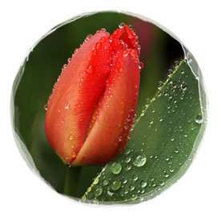

We had been preparing for this flight for a long time. Everybody arrived from different places, some from afar. Finally together all in one place, our dense crowd took off. As we flew overhead, we watched plains and woods, prairies and rivers float underneath us. It seemed like the nature itself greeted us.

During the flight I overheard my neighbors talking. They were discussing the future and the meaning of life. One of them was convinced that if we returned to the plains, we could be more useful there. Another dreamt of ending up in the ocean so that he could merge into its boundless waves. I really did not care to speculate; it was my first flight, and I wanted to enjoy it. Instead I was contemplating the inviting silkiness of the field and green trees on the hills below.

My neighbors kept arguing, almost fighting, when suddenly the commander gave an order to jump. All of us rushed down the aisle out the exit. We were falling from vertiginous heights. At first, I couldn’t see anything. The wind was beating in my face, and everything was whirling before my eyes. As I spiraled down, I could only make out a couple of houses and a bunch of boys pointing their fingers at us and impatiently jumping around.

A gust of wind took me away, and I saw the trees and their branches stretching towards us in excitement. I was suddenly filled up with delight, my body elongated. The wind was tackling me as I was gaining speed. Now I could distinguish the leaves sparkling in the rays of the warm May sun. This is when I heard a sound, as if somebody was clapping their hands, and I fell on a flower petal with a loud splash. It was over. I was happy.

The very next morning, a little hedgehog came out of its hole, licked a drop of rain from the petal, and gratefully looked up toward the sky.
A Losing Streak

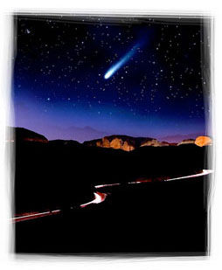

“We have discussed all the options and taken into consideration all the suggestions… Only a miracle can save us now. Does anyone have any other ideas?”
An old one stepped forward.

“Since all the rational suggestions have been exhausted, I will tell you about a miraculous place where stars are falling every night. They cut through the sky and disappear somewhere on the other side of the plain. If we all make a wish at the same time, our mental energy will combine with that of a shooting star and help us solve our problem. The journey there is long and hard, but if you are willing to try, I’ll show you the way.”

We momentarily gathered together in absolute silence. Upon agreement, we took only the essentials for the long trip, formed into files, and headed out. By noon we passed by a high mountain, had a quick snack, and kept on going.

The journey indeed was difficult. We had to constantly climb up and down. The old one was confidently moving forward. We crossed a deep den and started climbing up a mountain. The landscape was foreign and strange as if covered in trenches.

It started getting dark. We were now marching in a straight dense line trying not to fall behind one another. Finally, the old man stopped us with his gesture as we were approaching our destination. An extraordinary plain opened up in front of us. Its horizon was absolutely flat and even, without such a ripple like a single stone. It was gray and stretched as far as the eye could see.

Nightfall quickly fell upon us. We stationed ourselves on the last crest of the hills next to the plain. Suddenly the silent air was pierced, we heard a raging roar and soon saw a shooting star. We gasped and traced the path of the shooting star with our astonished eyes. It was blazing through the sky, amazingly beautiful, falling apart into a shower of tiny sparkles. Time stopped. Enchanted, we couldn’t move. We were following its magnificent path until it disappeared somewhere far away. Soon we heard a new roar, and the night sky was dissected by another star and then another one. It was a magnificent, glorious sight.

All of a sudden the brightest star flew towards us. Approaching swiftly, it was gorgeous and shining brightly in the dark. Amazed by such a stunning beauty and by our incredible happiness and sheer luck, we crowded to make a wish. But soon we realized that the star was heading right for us. We took off running and just barely escaped it. The star fell right next to us and burst into blinding fireworks. Everything around us caught on fire. Salvaging our future, we scattered in all directions…

A cigarette butt flew out of the car passing by, drew a beautiful arch in the air, and set the grass on fire on the side of the road causing the pilgrims to run for cover. With their last bit of strength, a colony of unlucky ants were saving themselves from fire.

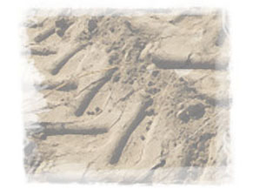

The Chase

It’s the dead of night. No one is around. You could hear a pin drop. Suddenly I see two eyes gleaming in the dark, staring at me not even taking a break to blink. I cannot see from the distance whether it’s a he or she. I dart forward following the trace, with my head pressed against the ground. It's pleasantly rumbling inside from the anticipation of an encounter.

I'm getting closer. It looks like it's a she. Knowing that, my excitement grows. I tighten up, my blood runs even faster through my veins. I growl and rush after her. Her eyes ahead are calling, but I’m hesitant to get too close. I caught up to her; we almost touch. She growls, starts blinking, jumps up, and speeds away from me. This turns me on even more. Her smell and those slanted eyes are driving me crazy. I roar and almost come in contact with her again.

And this is when I realized that no matter how hard I try, I could not possibly catch up with her. This force pulling me toward her was like a magnet, but a very strange one; one that draws us closer, but as soon as you are about to meet up, doesn't allow you to go any further. This is the same moment when you realize you can't proceed. You need to stop, or you'll face death.

I fell behind. Somewhat retreated, I still kept running after her. She gratefully relaxed. And all of a sudden, surprisingly, I felt the sense of intimacy. There we were, two lonely souls, who met blindly in the night and now were chasing one after the other. How amazing that our chance meeting caused all the darkness in this world to step back and set the heart at peace.

We kept running like this until the lights of the town appeared on the horizon. She winked at me as if saying goodbye and veered right toward the woods. I acknowledged her with my headlights and flew further, with my wheels gently rustling on the asphalt.

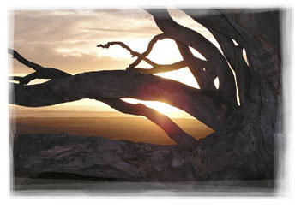

Concert

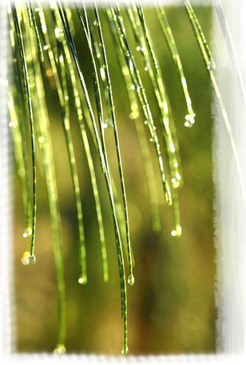

We liked to get together from time to time and play some rock or jazz. We never knew for sure when we would gather nor in what lineup, but for some reason they were always advertising our performance on TV. And all the locals treated this information very seriously. But the most astonishing thing is that they never came to see our concerts. Rather quite the contrary, they remained locked up in their houses. Why don’t they enjoy our music?

Once our boss – we call him Thunder – announced our meeting. We dropped everything and all got together. Everybody wants to get away sometimes from the daily routine. Our music turned out best when played in the open air next to the house of a strange old man. He seemed like the only one in this area who understood music, and sometimes he would even come out on the porch to listen to us. Next to the old man’s house, there were some pipes and casks. Together with the tin awning above the garage, they helped produce some great sound.

I know the little boys from across the street liked our concerts, too, but for some reason they were not allowed to come out to see us. They were being told that they could get sick. I wonder, how could you get sick from music? Oh well.

Today we all wanted to jam. Thunder turned on the light chaser, and we began. There were a lot of us today, and it seemed like everybody was in the mood for rock. I was bashing out on the drums, my friend was tearing up the strings, and the girls were fiercely banging the keys placed on the water pipes. A couple of new girls started dancing on the buckets left outside, beating out the rhythm with their bare heels. Some guys that I didn’t know jumped in with their drums and cymbals. Our lead singers and back vocalists grabbed the microphones and started screaming so loudly that my head was about to burst.

I couldn’t say that the concert was working out today in a harmonic way. The guys were trying so hard that some of them played off-rhythm. A guy next to me was trying to yell over the top of all of our lead singers despite the fact that nature had not generously given him an ear for music. One of the girls fell off the bucket and was now screeching like a rusted saw. The other ones were replacing the talent with desperate eagerness, but it seemed like everybody was really having fun. Even though it was pure cacophony, it was giving us an enormous energy boost – and it was totally cool!

Finally we got burned out and left our instruments. With ringing in our ears yet happiness in our soul by the end result, we went back to our business.

That day they broadcasted on the radio that it had been awhile since anyone saw such an intense thunderstorm and such a heavy pouring rain.

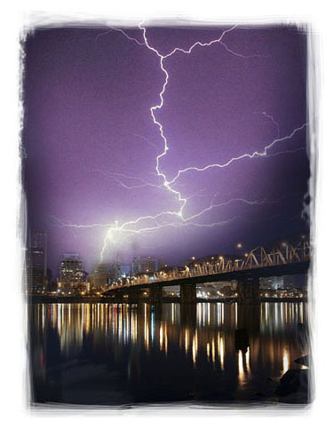

Friends


Her side:

The house was empty for almost a year and finally, at the end of May, it was bought by a young and what looked like a successful businessman. He flew up the stairs in his confident, bouncy gait, and I cheerfully greeted him. He smiled and came into the house.
Since that moment our relationship was off to a good start, and our summer life commenced. In the morning he would leave for work and at dusk, he would come home. Usually tired at the end of his day, as soon as he saw me, his eyes squinted a bit, and a smile touched his lips. Then he would come out on the porch, sit in the chair with a cup of coffee, and tell me about his day.

From time to time, he would bring his friends and colleagues around. I did like some of them; others not so much. But I was trying not to obtrude my opinions upon him and only occasionally offered delicate hints. As time went by, it seemed to me that he started to listen to what I had to say and bring business partners home to show them to me. We became united by an unspoken agreement. I was pleased that he valued my clear opinion.

Once he brought a rather pretty looking girl. She bounded up the stairs strutting her catwalk and came up to me. I jealously looked at her, was about to give a hum of disapproval, but had to admit that she didn’t look too bad. My buddy smiled as a sign that he approved of my self-control and valued our sincere friendship, and he invited her inside. Ultimately it didn’t work out for them, but this little episode drew us even closer.

His side:

I really started to enjoy returning home at the end of the day and hearing her happy greeting. Without noticing it, I became so attached to her that I couldn’t wait for the evening to quietly sit with her and share my thoughts. She had an extraordinary sensitivity for people. It wasn’t long before I purposefully started bringing my potential business partners into my house to see what she would say. It was sort of a test. She was greeting some composedly in a businesslike manner, was joking and playing with the others, and some almost didn’t notice altogether.

Recently I got a new boss that I couldn’t quite figure out. He was a dark horse to me, everything about him foreign. My boss was displaying sympathy, but there was something unnatural about him so I decided to bring him home to ask for her advice.

Her side:

One time he brought a disgusting fat man with a red face and puffed up, shifty little eyes. From the first moment I laid my eyes on him, I felt that you couldn’t trust that fat man. He was patronizingly tapping my buddy on his shoulder yet remained irritated and apprehensive inside. I let my partner know right away. Standing by the door, the fat man turned around and discontentedly yelled, “You need to replace that darn floor plank. It’s squeaking so nastily!”

“Good friends should not be replaced,” my friend uttered with a mysterious smile.

Bad Barber

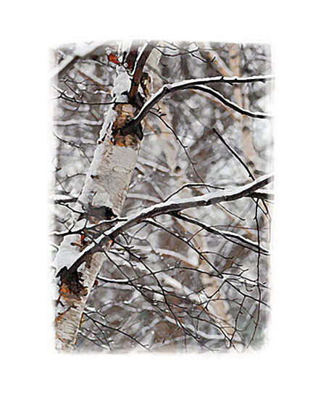

I must admit I am not young any more, and I should tell you barbers usually find me. The one I had before was cheerful, sociable, and hardworking. He was always so meticulous when cutting my hair, not a hair out of its place. I recall him always singing too. It was obvious that he was enjoying his job, and I was happy. It doesn’t matter how old you are, you always want to look good. And possibly even more when you’re older.

And here comes that one: young with headphones in his ears and a big wad in his mouth, constantly chewing like a horse. He brought some new fashionable trimmer and started clipping so hard and fast that my hair was flying all over the place. He bobbed me so bad, it was scary to look. His mane is long, up to the shoulders, and I almost got picked bare. He looked at me, gladly chuckled, and walked away without even an effort to pick up the hair.

Once beautiful and full, the jasmine bush met this fall with short nude branches.

Magic Flower

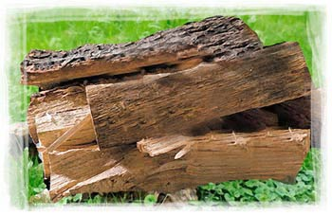

“I am going to tell you about a miracle," the old man began trying to get comfortable on a tree stump covered with a sleeping back. He dreamily looked at us and continued. “It’s a mysterious flower, very unique by its nature. It blooms on fallen trees or on logs just like that,” and he pointed at the pile of logs by his feet. “And as a rule lives only one night. If you stare at it and allow it to carry you away, you won’t be able to take your eyes off it.

It charms and almost hypnotizes, constantly changing its shape and illuminating everything around with its magical light. It breathes, and with every breath it changes its color and moves its petals. At first it’s orange, then it gradually turns into fiery-red and then becomes purplish, almost wine-red. Caressing the tree branches with its petals, it fills up the forest with an incredible, unmistakable aroma that always reminds us of comfort and warmth…”

The old man took a little pause and then continued, “As boys we worshipped it so much that we always brought our donations of cones and leaves to it, and the flower gladly took them. It flourished right in front of our eyes and made incredible sounds, similar to a clicking or crackle, and burst up its seeds. And sometimes those that didn’t fly too far gave birth to new flowers. Though afterwards we were yelled at for our adoration.” The old man grinned and got lost in his thoughts again.

“Yes…this is an extraordinary miracle!” he smiled and threw a big cone in the campfire.

In the Autumn Park

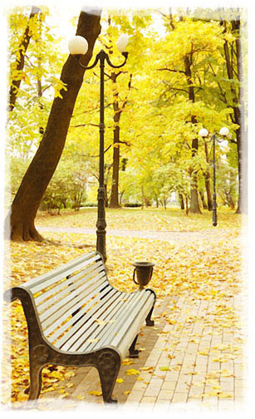

It was a sunny autumn day, one of the last ones at the end of September when the sun is warm, and it can’t help but make you want to smile. I took a seat on a bench in the park to enjoy the warm sunbeams and admire dear maples on the background of the radiant blue sky. It hasn’t been too long, and I still feel the internal bond with them.

Time is getting close to midday. A light breeze starts blowing. I see a bunch of cheerful old men and women in the alley. Radiating smiles, they are slowly walking, making stops at every step, quietly talking to each other. All of a sudden, I hear “Swish! Swish! Swish!” I can’t figure out what kind of sound it is, but for some reason, it seems unpleasant to me. I feel like it’s disturbing the harmony of the autumn park.

I allowed myself to dream and doze off for a bit. I began reminiscing of summer, youth, cheerful and reckless chatter with friends that would sometimes carry on into the morning hours. What nice carefree days they were! And I heard “Swish! Swish! Swish!” again right next to me. I hear indignant shouts around me: “What in the world are you doing? You show no respect to the old!”

I was about to flare up at them for disrupting my nap. My eyes opened, and I saw a bristling broom pointing right at me. Before I could open my mouth, the broom threw me up in the air and tossed me right into the crowd of old people, and we were all swept into darkness.

And the gloomy park cleaner kept cleaning the benches and sweeping the alley.

Swimming Pool


Lap, another lap…I start getting furious. How many times are they going to chase me around here? I begin swelling and become red. They must be kidding me!

An incredible story pops up in my mind. I was lying out in the sun relaxing, enjoying life and then... They... They came, snatched me up, dried me to a condition within an inch of my life, and threw me in a dark and stuffy cell. Then I was transported by either a train, or a ship – not an airplane, for sure. I was shaken, tossed, and finally thrown into this pool. I just wanted to relax, but no. The water is scalding hot. Now they force me to do laps. Why in the world are they trying to catch me with a scoop? Why are they dumping out the pool with me in it? Oh God, it’s so high! I was thrown right on the floor and lost consciousness.

A kind old man sipped some more tea and spit out a tea leaf onto the floor.



Starnet

ALTR: Finally!!! I was waiting for you to drop in.
LUN: I wasn’t really going to… it’s just that it’s raining tonight, and I can’t really see anything, it’s boring and gloomy, and there’s nothing to do. So I decided to stop by.
ALTR: Good for you. Aren’t you lonely out there all by yourself?
LUN: Sometimes, but people around are nice. They seem to be happy to see me so it’s not too bad:))
ALTR: What do you usually do in the evenings?
LUN: I like to climb as high as I can and look at couples in love. They are kissing, and I am smiling. I like to watch the water in the sea sparkle. Sometimes I wander and look at my reflection in a pond... But more often, I just dream.
ALTR: About what?
LUN: About how good it would feel to jump down while no one can see:)) and dance on the waves running towards the shore. And then roll and roll up and down the hills and fields and feel warm grass and its smell.
ALTR: Yeah…feels good, I imagine!
LUN: And sometimes I want to rush down the night highway and see all the oncoming cars going crazy when they come face to face with a giant headlight moving towards them.
ALTR: What a rascal!:)
LUN: True. Otherwise it’s boring, right? And what are you into?
ALTR: As it gets dark, I am here, in the Starnet, chatting with my friends.
LUN: How?
ALTR: How? Haven’t you understood yet, Moon? When it gets dark, we all go on the Starnet – our chat room – appear in the sky, and send messages to each other, blink at each other. Why did you think the stars blink in the sky?
LUN: :)
ALTR: Look, gotta go. My little ones are being naughty, also trying to get in here, and it’s a little too early for them. Gonna go put them to bed. Sunrise is coming soon. Come around tomorrow, ok?
LUN: Sure thing, Altair, see you…

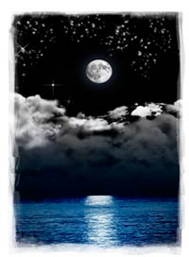

365 Degrees

It’s loud and noisy from all the voices in the auditorium; everybody is trying to shout each other down. A discussion of new standards is taking place.

“Dear friends and colleagues, I am asking for quiet. Professor N., head of the Department of Standardization, is now going to make a speech on clarification of new amendments.”

Silence reigned in the auditorium.

Professor N. commenced:
“Dear colleagues, we all know that the Earth rotates around the Sun and makes each of the circles in 365 days, or to be more exact, in 365.25 days. It means that in 365 days the Earth turns around, i.e., makes a 360-degree turn. In order to simplify the measurement system, we suggest considering a year to be 365 days long and a full rotation, or full circle, to be equal 365 and not 360 degrees. It will lead to the introduction of the mathematically perfect system: in 365 days the Earth will rotate around the sun and thus make a 365-degree turn. It will considerably simplify everything. We will simply modify the notion of one degree, since it is already a conditional term, so one degree will be equal 1/365 of the circle. Thus the right angle will measure 91.25 degrees.”

An explosion of voices ran through the auditorium.
“Do you realize what you are suggesting?”
“Everything will need to be changed! This is extremely hard!”

Professor N. continued:
“Of course, it is hard. But look at the Americans – they are, without any doubt, still having a hard time measuring the length in inches whereas everybody understands that metric system is a lot more efficient and convenient. You need to realize that despite temporary difficulties during transition, it is worth doing. Do you agree with it? We could transfer to the measurement system of 365 degrees.”

The rumble grows.
“Professor, if you consider the metric system universal, why don’t we introduce a 100-degree system where the right angle would be equal 25 degrees?”
“What about this ¼ of the day? Or maybe we should use a 100- or a 1000-day calendar?”
“And the Chinese calendar might have a different number of days. How about a Gregorian or Julian calendar?”
“What can you say about Incas stone calendars; did they have amendments too? And what about Stonehenge?”

Professor N. replied:
“We simply suggest introducing a 365-day calendar.”

“Professor, what can you say regarding existing technical devices? It all can cause global changes after all.”

Professor N. went on:
“Not necessarily. Already existing devices will remain the same. If they contain a right angle, it will remain right, only we will know that it is 91.25 and not 90 degrees. As for the mathematical formulas, well, they will need to be changed as well as most of the manuals and reference books. But the essential thing is that, in a long perspective, introduction of the new standard will simplify…”

Another explosion of voices broke out in the auditorium.
“Professor, what if, as a result of this conversion, something important for the planet is violated, and it will lead to changes in nature?”
“Professor, we cannot operate with such global phenomena!”

Both in the auditorium and outside there was a continuous roar of noise. You couldn’t hear a thing other than the tumult.
“How do you imagine…”
“What’s going to happen with…? How is it going to affect…?”

Professor N. exclaimed:
“Listen, listen. There are no global changes. Why is there such a horrible rumble everywhere?”

Recently created super ballistic missiles of the class “Green World” were soaring in the air and tearing the Earth apart creating deep fractures in the body of the continent. A huge lump of it split from the mainland was slowly drifting in the boiling ocean. Scientists preoccupied by the changes in science and nature weren’t noticing anything going on around and kept up their heated debates about introduction of a new standard.



Divine Message

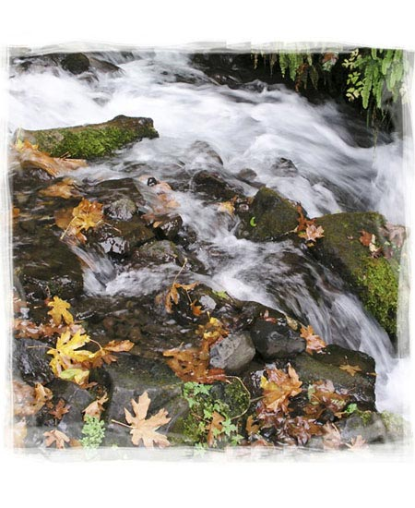
Long, long ago at the dawn of civilization, the Gods were having a discussion on the mountain of Olympus.

“The time has come to pass this knowledge to the people, but they are not ready for it yet. This knowledge has such a great power that a person who is not ready to receive it and who uses it carelessly may turn the very essence of people’s existence and the Universe upside down.”

“It means we must keep it safe till the future, since this knowledge is the main secret to humanity. We need to carry it through the centuries and millennia and reveal it to the people only at the moment when they are truly ready to accept it.”

“Yes. A New Man should come; only he will be able to learn the truth and show humanity a new stage of the development of civilization.”

“We don’t have much time left; however, before that moment comes, we need to hide this knowledge so that the contemporary man can’t find it, yet it would reveal itself to the New Man.”

The gods were discussing, arguing, building theories…day succeeded night and night succeeded day. At the end of the seventh day, the Goddess of Water made a suggestion:

“Let’s encode the knowledge in a message and hide it in everybody’s sight, but so that an ordinary man, looking at it every day, wouldn't see anything. However, it is necessary to arrange it so that when the New Man appears with his unique abilities and unique sensitivity to nature, he would be able to see that message and decode it.”

“We agree. For encoding we can use three elements -- earth, air and water -- to reveal our message to the Man wherever he appears.”

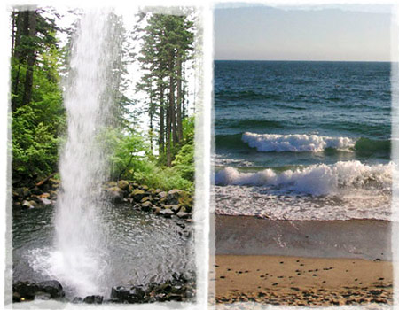

“In the mountains and forests, we will use rivers. While streaming down, the water will be murmuring down the stones. A harmonious melody will be playing in the air backed up by the prattling of the stream and the jingling of little waterfalls and splashes. It will be heard far and wide. For an ordinary man, it will be not more than just the gurgling of water; but the New Man will capture the whole scene and be able to hear the message encoded in the murmuring of the stream.”

“In the canyons and valleys where there are no rivers, we will create such a wind-rose that the message will be encoded in the howling of the wind.”

“On the sea shores and ocean coasts, we will encrypt the message in the near-shore waters. During periods of flood and ebb, the wave washing the shore and touching stones or sand will be daily sending the message in the sounds of the surf. The wave will be talking to the Man, and one day he will hear it.”

“In the desert, we will unite the elements of earth and air, encoding the message in the patterns of dunes and sand drifts. The wind will be creating these patterns in a certain way to conceal the secret within them. At a glance it will seem like the desert is simply covered with a shawl of dunes, but the New Man will be able to see the pattern and decode the message.”

So here they decided to agree, encoded the message to the New Man, and started sending it day after day in expectation of a long-awaited transformation of the man.

And only the god of the fourth element, the God of Fire, who wasn’t involved in the discussion, was jealously breaking the agreement trying to rebel. He was causing volcanoes to erupt, continents to move, and deserts to quake. But every time order was restored, and nature continued its patient anticipation. So it happened that, in order to learn the True Knowledge, people progressed further in studying water, air and earth. Fire, however, still remains the least explored element.

But maybe the time of the New Man has indeed come? Don’t you think that water in mountain springs is murmuring on its own without any purpose or that the ocean brattles just to hear its own voice?

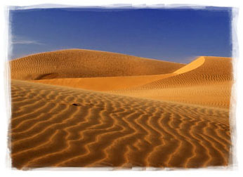

Julia Valenskaya
One-cup Stories

Editor Alla Valko

Many thanks to Olga Lynn, Lori Bean and Russ Melvin
for your help with translating the stories.

© Julia Valenskaya. Texts. Illustrations
www.valenskaya.comwww.onecupstories.com

All rights reserved. This book is only for personal use. You may not distribute, exchange, modify, sell or transmit anything you copy from this book, including but not limited to any text or images, for any business, commercial or public purpose without author's permission.

