Julia Valenskaya

One-cup Stories

Collection 2

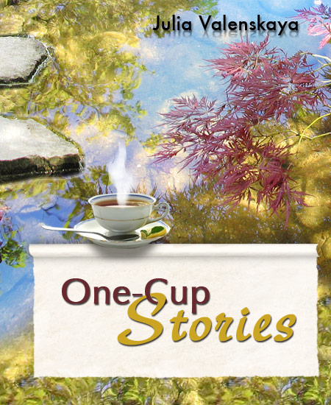

Everlasting Love



I am sitting on the beach leaning against a huge piece of driftwood. The sand is warm from the mild October sun heating it throughout the day. The wind is tousling my hair and rustling the sand over my notebook. The ocean in front of me roars with its deep voice and sometimes profoundly sighs. Next to me a cliff thrusts her feet into the ocean, and the ocean crashes himself against her trying to reach higher and higher.

“Sweetie, stop roaring. I am right here. I can hear you fine.”

“I want to feel your whole body, each of your curves. I want to penetrate into each of your clefts and be closer to you.”

“I know, honey…”

“I fell in love with you at first sight! I remember the day when I first saw you, still a barefoot little girl with angular knees and shoulders. You appeared here, sat down, thrust your feet into the water, put your chin on your knees, and set your eyes on me. Life stopped; the sounds faded. For the first time in my life, I froze and got paralyzed by shyness and an incredible excitement in my soul.”

“I remember that, too. You were mighty and splendid, shimmering with all the shades of blue, my favorite color. I remember your reaction, and I couldn’t understand where it was coming from. You were raging by my feet and throwing bounties of foam at me.”

“I wanted to sense you, so divine. I wanted to love you, and my heart was longing for you. I wanted to grasp you, cuddle up with you, and hold on like this forever, but I feared of scaring you away with my impulses.”

“Yes, sweetheart. Do you remember how you weren’t letting anyone else approach me?”

“I know. I didn’t know much back then. I was afraid they would steal you from me…”

“Silly…I never needed anyone but you. People, animals, and birds were coming and going; the years were flying by; the sun was warming my shoulders; the sky was flaming at the sunset; and all I needed was you. You were all that I saw.”

“I wish I knew back then. I sank so many ships in vain fighting for you.”

“Do you remember the first time we made love?”

“Of course! It was sunset, the sun was gleaming on your chest, your hair was waving in the breeze, and the pink clouds were caressing your neck and shoulders. You were so gorgeous, you were Beauty itself! I went insane from the delight, and my waters roughed. I raised such enormous waves that they engulfed you. I wanted to touch you with each of my drops. I yearned for a moment to snuggle with you, to break through every restraint, and to scream with every raging wave: “I love you! I want you!”

“I remember that, too. Your caresses were driving me crazy, and I couldn’t believe in my newfound happiness. I was scared. You were overwhelming and smothering me. I could feel your passion and knew that you loved me and would never hurt me. And then I opened up, pleading for all your mightiness, craving for you to fill me up so that I could feel you with every one of my grains of sand. You flooded me. It was the most stunning and wicked storm. The nature itself was living our love. The sunset spilled all across the horizon, the seagulls were fiercely rocketing up into the sky, and the agitated sun was highlighting the blades of the waves. They were blinding me and collapsing over my shoulders. We were screaming, screaming of joy, love, and victory – victory over time and fate! We were screaming until we wore ourselves out. We were tired and content. You were swirling around and hugging my feet. Then the sky grew dark, and the first timid star lit up in the sky. It was shining only for us. Do you remember?”

“Yes, darling. I remember every moment that we spent together. So many years have passed, but still every day at sunset, I wait for you and get excited just like that first time…”

“And I always come to you. My sweetheart, I am with you forever. Don’t you understand? Don’t roar! Take my hand, and let’s just quietly sit together and watch the sunset. It feels so good being with you.”

“And I will continue hugging and kissing your feet so that you can look at the sunset and dream. You will remain the little dreamer forever, my love. And I will try to calm down for a moment. It’s not just because they call me Pacific…"

"I love you!”

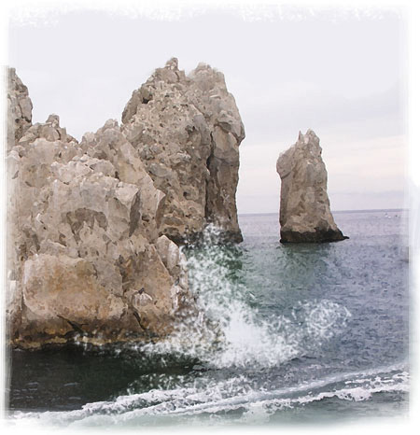

The Flight

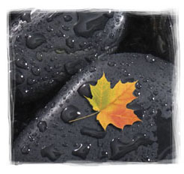

Finally she felt that long awaited freedom, and she flew. What a pleasure it was, a feeling of boundless happiness and joy! She was spinning with her head thrown back, singing and laughing out loud. She absolutely didn’t care if anyone could see or hear her. She was gliding in the transparent, slightly frosty air, clothed in all amber yellow, with her arms wide open, imagining that she was dancing a wonderful ballroom dance.

The season was over. Most of her friends had already flown away, each going their own way. The parting was sudden and sad accompanied by the harsh rattle of cold rain. She was much luckier than her peers. She was leaving on a beautiful day when the sun was shining and nature stood still, enchanted.

She veered over toward a small pond containing a little rickety wooden bridge. So often had she been looking at it from above and dreaming of flying one day over it just like that, free like a bird. She flipped on her back, and put her arms behind her head. Serenely, she gazed at the sky and let the wind carry her.

Suddenly she caught notice of him. First, she saw his eyes staring at her and following her every move. He was gliding above her, all in red, and even blinded her for a moment by the sunbeam that reflected off of him. She halted in surprise. He was charmed by her childish spontaneity and true expression of happiness that was tempting him so much.

They couldn’t take their eyes off of each other and quickly began moving in closer feeling an impulse of attraction. Their hearts welled up with joy. The wind grasped hold of her, and she started rapidly spinning trying not to lose the view of his eyes. Alas, their eyes and hands met, and the whole world disappeared leaving only their eyes filled with boundless tenderness and delight. His fingers were warm, and that warmth passed along her arms and shoulders producing a fiery wave that broke into her heart. She couldn’t believe that she would fall in love on this wonderful day. Her heart was screaming, “Yes!”

At first they exchanged timid smiles, then started giggling, and then laughed out loud as hard as they could. They were so happy that they had met each other and that their paths had crossed right here, at this very moment and that nothing could pull them apart. They simply did not want to think about the future nor their destiny. They were just spinning, holding each other’s hands and looking into each other’s eyes. The whole world concentrated on these adored eyes. They were singing and laughing while slowly drifting down towards the ground.

The Goddess of Nature was looking with sorrow and fondness at the two fallen leaves, a yellow one and a red one, dancing in the air with their stems intertwined. She was happy that, at this last moment, she gave them love; but she was sad, too, because this love wasn’t meant to last. Their magnificent dance would be over as soon as they touched the ground. She blew a gust of wind on them to prolong their happiness. They kept spinning and looking at each other acknowledging that there was no bigger joy for them in the whole world.

Soon they quietly fell down all the while cuddling and gently hugging each other. A new life was about to begin for them, the life of contemplating the beauty that surrounded them. They felt warm and safe together.

The Goddess was crying, crying with tenderness and joy that despite her they were happy in their love and understanding of wisdom that just had revealed itself to them.

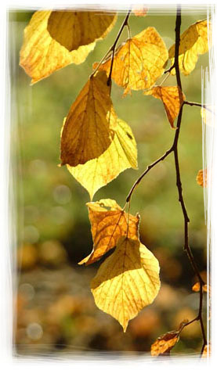

The Dream

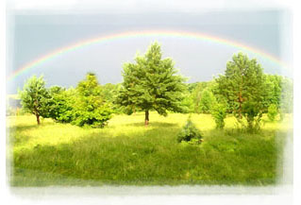

I was sleeping.
The Dream snuck up on me quietly, danced up my arm, sat on my shoulder dangling her feet. Then she tiptoed across my cheek and gently kissed my eye. I woke up, but fearing to scare her away, pretended that I was still sleeping. She drew her fingers across my lashes and then nestled in the corner of my lips hugging her subtle knees. Her sight was bleary, her chest was slowly heaving. The Dream was dreaming...

A little while passed by. She briskly stood up, threw back her shoulders, ran up across my cheek again, and knocked with determination on my closed eyelid. I opened my eyes and saw an ocean’s depth of tenderness and love in her eyes, yet also a firm appeal: "Let's go. It's time!" I understood that she would show me the most essential, most sacred thing one lives for. She gave me her hand and asked me to follow her. I grabbed her little palm and had a strong feeling that I should never let it go. She turned around, looked at me – surprised at first, then approving – nodded, and we took off flying.

The most amazing places that I could ever imagine were floating beneath us – flashes of memories and reveries of my childhood. They were calling me with their fresh greenery, bird warbling, and joyful colors of flowers. But I kept flying. It seemed to me that something more important is waiting for me ahead.

Soon I heard the clear laughter of children. My heart filled up with happiness, and I rushed toward the jovial voices. The sound was coming from the bushes on a meadow. I was circling above it, peering into children’s faces, trying to understand if those children were mine. But something was still calling me forward, and I kept firmly holding the Dream's hand.

From time to time, she would turn around and look in my eyes as if she were asking, "Is this what you wanted to see or do you want to fly further?"

We were flying and flying, and there was no place in the world more wonderful! Each new view was better and more fascinating than the one that preceded it. My heart was singing from such magical beauty. I saw my friends, co-workers, and some people that I didn’t know. But I kept flying forward holding the Dream by her hand, believing that she would soon reveal something that I’ve always been dreaming of, something so intimate that I could never speak about it out loud.

Suddenly, I heard the sound of His voice, so dear and long awaited. It seemed like he was calling me. I was torn trying to figure out where the sound was coming from. My heart started leaping frantically; my cheeks lit up. I passed my hand over to my face to get rid of this apparition, and in doing so I let go of the Dream’s hand for a moment. As soon as I did that, I realized that I was falling.

I was falling from a dizzying height, trying desperately to catch the Dream’s hand, but it was escaping me. Our eyes met; mine were begging for salvation. She was stretching her little arms toward me, but I couldn’t reach her hand. I watched her floating further and further away from me up in the sky. She was crying, and only her bitter tears were following me.

I was crying too – from the regret of losing my dream, cursing her for having let me fall, and also cursing Him, who, even though his call was so long-awaited, he beckoned my presence at exactly the wrong moment. My heart filled with sorrow that perhaps the dream would never return. I was just beginning to dream!

And then, I saw Him. He was sitting on the bench in the park admiring the first yellow leaves of the season highlighted by a lazy September sun. He raised his eyes, our eyes met, and I forgot about everything else in the world. In this short moment, I understood that this was Him, the one I needed so much; He, the one I was waiting for for so long. I believed in the endlessness of this moment and rushed into the heaven-sent depth of His eyes.

He opened his arms towards me, picked me up, and we fondly hugged. Moments later he was kissing my eyes, lips, and shoulders, and I saw the tears of joy in His eyes. I looked up in the sky, and it seemed to me that the Dream was happy for us, and I knew that she would come to me again some other time.
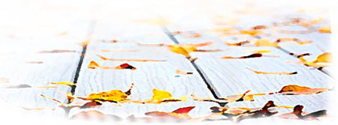

Rainy Night

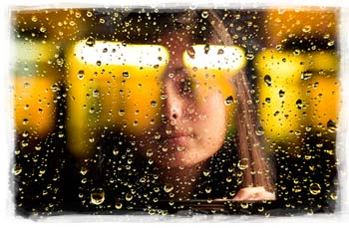

Some unknown force drew me to the window, and I saw her. She was standing in her light nightgown with her forehead against the cold glass. Her eyes were filled with unexplainable anguish. Our eyes met for a moment, and I felt like she was looking through me. Is it really so dark here that she can’t see me? I was trying to yell something to her, but the wind carried my words away. She kept sorrowfully staring through the window into the cold darkness of rain that was disturbed by rare flashes of lightning.

A lamp was lit in the room next to her bed; it was softly highlighting the curves of her shoulders and neck. The light carefully followed the oval perimeter of her face, streamed down her hair, jumped off her cheek, slid down her shoulders, and disappeared somewhere on her back. I got closer to her cheek and slightly touched it with my lips through the glass. Then my eyes slid further down fondly caressing her neck, then stopped for a moment trying to get inside the opening of her gown to touch the timid semicircles.

At this very moment, I felt another set of eyes looking at her. A wave of jealousy flooded my heart. How dare he so blatantly stare at her, my divine. I couldn’t stop the anger from growing within. I wanted to grab him and throw him far away from here. I jumped on him, and we grappled like hungry wolves. We got hold of each other and started impetuously falling down.

Everything was rotating before my eyes. At some moment I caught the outlines of her waist and subtle dimple of her belly button. Then I saw black trees and wet redheaded lights on the background of a dark blue city sky, and finally, I spotted the raging sparkling eyes of my opponent. With a loud roar and splash, we fell on the windowsill and landed in a whole puddle of fools like us, the fools who were trying to fight for the right to stay there on the windowsill, for at least a little bit longer and steal one last look at her.

But, as always, the force of nature prevailed, and we streamed down. While I was falling, I saw as she traced her finger down the glass following the path of a raindrop and finally smiled. Jealousy faded away, I was happy for her, and the river of life carried me further…

Summer Day

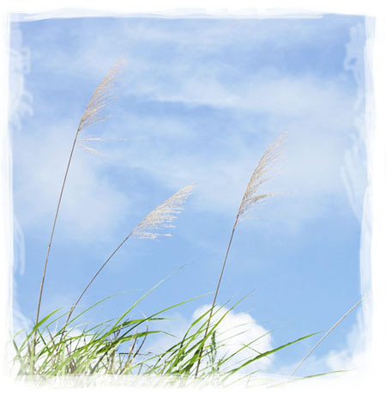

Have you ever lain down on the grass when the air stupefies you with the smell of flowers and jingles with the chirr of grasshoppers? Do you know the feeling of lying down and peering up at the sky through the tall blades of grass, and it seems as though the flowers reach up to meet the sky? Here is a little story about it.

It’s summertime. You can hear laughter, sounds of voices, the chirr of grasshoppers, and the buzzing of bees in the air. At last the long-awaited day has come – she has finally come of age and was allowed to open her face. She could hear voices from everywhere: “See how beautiful she is! Her eyes are shining so bright! What an amazing grace! She is simply gorgeous!”

She is standing with her tender cheeks turned towards the sun, stunned by the abundance of the sounds and bright colors. Her sisters are whispering to each other next to her, winking at the young princes. Everybody is filled with careless joy and is looking forward to an approaching holiday – the summer ball of the flowers.

She raised her eyes and was instantly charmed by the blue sky and the clouds that were peacefully floating in it. They were gliding by slowly all the while changing their shape. Here is one…It seemed to her that she had seen it in her dreams. She didn’t know then what it was, but the image of it had always spoken to her. And now the cloud is so close... but FLOATING BY!

The sisters are poking her, “Look at that prince. See how handsome he is!” But she can’t hear anything and keeps looking up in the sky. Her cloud is floating further and further away, and she feels so helpless. I am standing here watching it float away, and I am not even able to scream to him: “Stop! Where are you going? I am here, on the ground! Look at me! Today is my day, my first day! Where are you going?”

Suddenly the wind came along and whispered in her ears, “If you want to, fly to him!” She looked at her sisters but they just kept laughing without noticing anything around. Then she raised her eyes and gave herself to the wind. Tender pink petals came off the flower, and as if dancing in the air, they began slowly floating up into the sky. Everybody froze for a moment. “How is that so? How could she, being so gorgeous, end her life as a flower on her very first day? This is against all the laws of nature!”

The petals kept rising higher and higher into the sky until they could not be seen from the ground. All of a sudden, one of the clouds in the distance became a bit pink, and everybody felt that someone up there in the sky had become happy.

Memory Collector

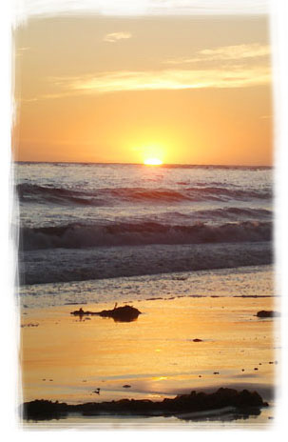

Thanksgiving Day was approaching. Not quite the holiday when people were thanking the abstract turkeys who had saved the Americans a long time ago. No, now this tradition seemed absolutely unnecessary. Instead, we’ve finally learned to appreciate other people and say thanks to them at least once a year for the moments they'd created for us and that remain so valuable to us.

You sent me a present, a little black box tied with lace. The box smelled like the sea, wet sand and some exotic trees. I opened the box and saw a small – about five-minute capacity – memory collector. It resembled something like a photo or video camera that, besides everything else, could memorize smells, sounds and feelings.

I pressed the play button already feeling anxious that it wouldn’t be revealing simple memories. I saw a room in the gray of the dawn with us in it. You had the expression of endless love and delight in your eyes. We were far, far away on the other side of the earth, and there was no one else around. I was next to you, so yours, so pretty, so earthly and so unearthly. My face was highlighted by the first rays of the sun. You raised your eyes and saw the incredibly beautiful sunrise.

The sun in its triumph was coming out of the sea line, illuminating everything around, spilling gold on the surface of the water from edge to edge, dancing and running on the waves towards the shore, and finishing on my nose and chest. And I watched while boundless happiness had engulfed you. That sunrise was symbolizing the beginning of new life and love. You felt that our love had passed the rite of initiation by the rays of the sun and it covered you entirely.

The time was up. Your memories have agitated a whole bunch of mine, so different and almost forgotten. You thank me for that day, but it was so long ago. Why now? Why not back then?

I have a whole display of such memory collectors on my fireplace mantel. Why am I keeping all of them? Here we were on a train. It’s night and silence veils the sky. All of a sudden, my heart exploded into millions of lights. It was like the birth of a Nova with a furious heat eruption when the whole universe was trembling. And from this explosion, everything around burst into flames of love.

The streams of lava splashed in all directions and engulfed my brain. For the first time, I realized that I loved you. Such a simple thought emerged like a revelation, like enlightenment. Unexpectedly all my effort to fight with you and with myself disappeared. The walls that I’ve been building so meticulously collapsed. Then I felt the radiant glow coming out of me, the light of those same rays that you saw later on there on the seashore. So many different memories… It was so long ago…



The Snowflakes



Once upon a time, there was a little girl who was dreaming of a little white horse. It was wintertime, and she was picturing the little horse in the ice ferns and in the clouds. It was all she was talking about. Once when she was already sound asleep, a fairy came to her, sat on the edge of her bed, petted her on her fluffy little head, and said, “There is a magic time before New Year’s Eve when it’s snowing, and beautiful white snowflakes are falling from the sky. They are dancing and slowly falling to the ground, and each of those snowflakes is somebody’s most cherished dream. If you catch that very snowflake of yours, your dream will definitely come true.”

The next morning the girl woke up and peered out of the window. Everything around was white and it was snowing. She ran outside to catch the snowflakes. The girl was running around the yard, stretching out her little hands toward the falling snowflakes, grabbing them with her frozen fingers and her mouth, and following them with her happy eyes. New Year’s Day soon arrived, and she got the most beautiful white plush little horse. The girl was overjoyed!

Many years had passed. The little girl turned into a young woman. The New Year was approaching. She was dreaming about happiness. She wanted to meet Him, the one and the only one for her. She knew she would recognize Him the moment she met Him since her heart was longing for Him for so many years.

One evening she was sitting in the kitchen, slowly stirring tea in her cup, and dreaming to some quiet music. Unexpectedly she remembered the story of her childhood and smiled, then giggled, ... shook her head... and looked out of the window. It was again snowing. Giant snowflakes were dancing in the air, and highlighted by the rays of the streetlights created a magic halo around them. She forgot to get dressed or shut the door before she jumped out on the street and stretched her hands toward the falling snowflakes.

They were falling on her face and hands, got tangled into her hair, and sat on her shoulders and chest. Her feet were freezing with only tiny home slippers on. The snow was forming a little hill around her feet, but she kept stretching out her hands, and gradually happiness was filling her heart, just like in her cloudless childhood.

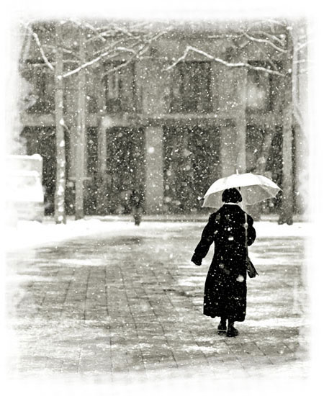

On The Lake

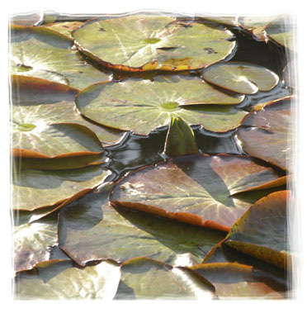

Summer heat. A nice cool, fresh breeze is blowing from a small lake surrounded by willow trees setting an enchanting atmosphere of serenity.

Finally I felt that long-awaited rest. On my back, I plunged into the refreshing purity of the water. Suddenly I heard a terrifying noise. I spotted something huge and scary, as if it was coming from a nightmare, headed towards me. A giant dragonfly made a circle above me and then landed on my stomach. I froze, all of my limbs lifeless from fear. I could feel a lump forming in my throat. The dragonfly threw a glance at me with its enormous shiny eyes, opened its mouth, and stretched its long legs toward my face. A hollow groan came out of my throat. The dragonfly rubbed its legs, ran them over its transparent wings with green veins, and abruptly flew away from me. I took a deep breath trying to calm down my leaping heart.

Soon the air was pierced by another rumbling sound. A huge bird landed on the branch of a willow tree next to me. For some reason the bird seemed more harmless to me. It was hanging from the branch and, as if not seeing me, looking at its reflection on the surface of the water. The bird was so close to me that I could see each of its feathers shining in the sun. Out of nowhere, the wind picked up. The sudden gust caused me to weave and made ripples on the water. The bird sailed up in the air and disappeared.

The gales of wind grew stronger; they carried me along the surface of the water. Terrified, I started looking around trying to figure out what to grab a hold of, and at this very moment, I saw another swimmer fighting with nature. It was apparent I had company.

“All right. Calm down. Don't be nervous,” I recited to myself. "Men like to help the weak and helpless, but hate when somebody's panicking next to them." I tried to make my face look calm, however, I kept getting carried forward, and fear was engulfing me wave after wave. He was being carried too and gradually getting closer to me. "Slam!" With all my might I hit my head on a tree branch that had fallen into the water and I lost consciousness.

A little bit later, I came to my senses and discovered that the wind had relaxed, and we were still lying in the water by the fallen tree. My head was resting on his shoulder. I couldn't remember how I ended up in such an unambiguous position and preferred to close my eyes again and enjoy the moment…

Two leaves carried by the wind up to the fallen into the lake branches enjoyed the reigned peace and tranquility.

Legend about Earth

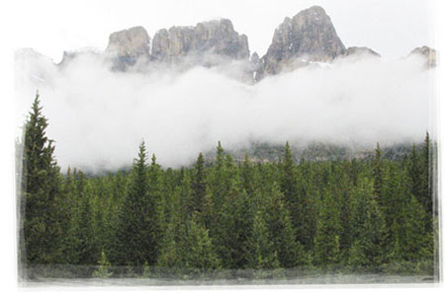

One evening I was slowly walking along the city park. The city was covered with dense fog that was enveloping the trees and the streetlights. Then I saw a lonely streetlight next to a tree highlighting the fog around it. I thought at that moment about whom it is shining for and wrote this story.

The Earth was born at the dawn many, many years ago, and she was strikingly beautiful. As a child, she ran around naked playing in the sunlight, full of cheer and happiness. Years have passed, and she turned into a pretty young maiden. Once she raised her eyes and saw the beautiful blue sky above her and fell in love.

And the Earth started dreaming about him. She was so eager to throw herself into his arms and hug him. So, she started growing trees, her arms stretching towards the sky. She gave birth to various beautiful trees to attract his attention. She grew as many branches as she could so that, with each of her fingers, she could touch the sky and enjoy being close to him.

Centuries have passed. The Earth has become a gorgeous woman and could not stay naked anymore. Now she allowed herself to get dressed by the latest fashion, to be wrapped into the ribbons of roads and decorated with the necklaces of cities and towns. She kindled her necklaces to illuminate herself and to appeal to the sky. “Look at me! See how beautiful I am! Come to me!”

Sometimes, when the jealous sun can't see them, the sky throws himself into her arms and gently wraps her with the blanket of his tenderness, with the fog. And in the morning, we can see dew – their tears of love and happiness.

Stereo System

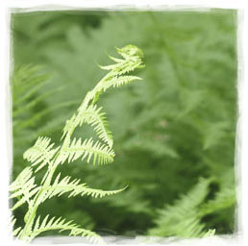

My wife and I have wanted to make such a gift for us to enjoy for quite some time. We were preparing, even arranging, a music room in our house. And finally, shortly before New Year’s Eve, we brought home a new stereo system.

The first couple of days, we were both listening to it all day long. Now we are trying to take turns depending on who is home, and, frankly, we are getting very tired of music. The new player turned out to be a very unusual device. Unlike standard ones that play music when you put in a disc, ours works the opposite way. You insert the disc, and it gets quiet, but as soon as you pull it out, it starts playing so loud that ears pop and walls vibrate – and all that at very high frequencies.

I tried to adjust the volume, treble, and base, but it didn’t work. I tried putting in different discs – the sound disappeared; it looks like it doesn’t matter which disc it is. After the system has been playing for a long time, it overheats and soon shuts itself off and snoozes. And only then can you finally enjoy long-awaited silence.

Believe it or not, within only a few days, I really learned to appreciate it. I was making sure I put the disc in on time and kept checking that the drive was closed and the disk hadn’t fallen out of it. Another thing that is curious is that it looks like our stereo likes when there is music around or when we are singing ourselves. We were told that if the player doesn’t accept discs and plays without proper authorization, we can hiss or monotonously buzz to mock that of white noise or the noise of the radio when the frequency is not set up right.

All in all it turned out to be not that simple; this stereo system requires a lot of care. You probably wonder why we even need such a “musical miracle.” Of course, this stereo system causes all kinds of nuisances, but there is nothing better in this world. Here he is, our baby, lying down in his bed, wheezing, sucking on his disc – the pacifier – and getting ready for work, gathering strength for the concert. As soon as he is awake, the whole house will tune up.

Anticipation

The woman looked at the freshly made up and decorated room with satisfaction. She grabbed two glasses, turned on some romantic music, and lit the candles. She barely touched me with her warm delicate fingers and yet she woke up life within me. She filled up the glasses to the top; I slightly touched her lips. She smiled and, in a dancing pace, came up to the mirror.

The woman was radiantly glowing and flying around the room in her long pretty dress with the long slit up the side. She must have chosen the dress for me to appreciate her beautiful body. While she was walking, her dress slightly opened, and I could see her exquisite slender leg. And either from the alcohol that I just had or from the exciting sight, my eyes dimmed, and I felt myself begin to melt.

She came back to the table, fixed the napkins, moved the candles, and raised the glass. I touched her lips again, and she blushed. Suddenly the doorbell rang. She rushed to open the door while fixing her hair and disappeared out of my sight.

I heard the sound of a man’s voice from the hallway. I was vainly trying not to heat up too much or get jealous. I did my best to turn into ice and remain myself, but I couldn’t. She had already melted me with her soft hands, and there was no turning back. They were whispering about something by the door for quite a while. Then I heard her clear cheerful voice and the sound of kisses, and for some reason, I started laughing. I looked at myself from the outside, and the situation seemed absolutely funny to me.

When they entered the room, a cube of ice was cheerfully melting in the cocktail glass.



Family

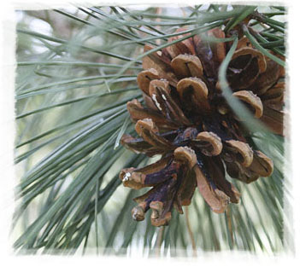

I have a big happy family. Take a look at our picture. This is me with two of my older brothers in the front row; you can see our younger brothers and sisters with their families in the central one, and at the very top – our juniors.

As for us, the oldest ones, we set the spirit and the style of the family. My brothers are solid, their bodies are those of giants; at the same time they are serious and pensive. Our middle ones, as soon as they grow up, are trying to create a family. They see their mission as expansion of the family and continuation of the clan. Here in the picture are their kids softly hugging their parents. Our juniors are always having fun, chatting, constantly moving and growing stretching towards the sun. They recently began donning a new fashion: their hair is sticking up like porcupine needles.

Everybody in the family is calling me a “shrink”. I have my own “therapeutic chair” and a curative aura. People often come to see me and trust me with their secrets. Many years of experience have proved that I don’t even need to say anything; I just need to listen. They take a sit in my chair and share their problems and thoughts with me. Sometimes though there are people who just come and keep silent. But it appears that this silence does them good. After they have sat like this thinking about their own business and sometimes sighing, I can see peace in their eyes and feel satisfied myself.

From time to time, old women gather for a "therapeutic talking treatment." Those women talk non-stop. One is complaining about life; the rest assent and join her. In reality they only increase her resentment. No matter how much they gossip about their families and stir up their problems, it turns out that one of them always feels offended and sorrowful. Then I feel like comforting them. In my mind I pass them my energy so that their troubles wouldn’t seem so hard.

It happens so that couples come over. Some are sitting, holding each other’s hands, looking into each other’s eyes, talking about love. I can listen to such for a long time; it’s pleasant to see such warm and fond feelings. But sometimes a different kind of couple stops by; they start sorting out their relationship, reproaching and blaming each other, screaming. I look at them and want so much to say, “My dear people! Look around. It’s peaceful and beautiful here. Forget about your minor issues. Your life will fly by so fast that, if you waste your time on useless arguments, you won’t have enough of it to enjoy this beauty. Value each other!”

But on the other hand, who am I to give advice? I’m just a pine bough more than a hundred years old.
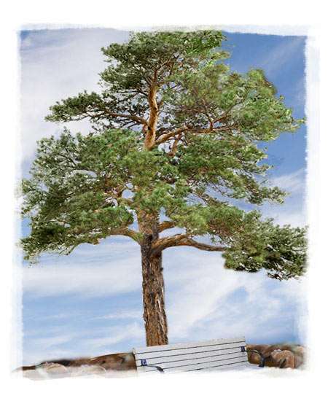

Julia Valenskaya
One-cup Stories

Editor Alla Valko

Many thanks to Olga Lynn, Lori Bean and Russ Melvin
for your help with translating the stories.

© Julia Valenskaya. Texts. Illustrations
www.valenskaya.comwww.onecupstories.com

All rights reserved. This book is only for personal use. You may not distribute, exchange, modify, sell or transmit anything you copy from this book, including but not limited to any text or images, for any business, commercial or public purpose without author's permission.

